**MARQUEE RULES:**

**EX.NO:1**

**DATE:**

**AIM:**

To create a web page using marquee rules.

**PROCEDURE:**

1. Start the html, head and title of the page.
2. Using the marquee tags.
3. Mention the direction such as right, up, down, left.
4. Close all opened tags.
5. Save the file with extension as filename.html.
6. Run in web browser.

**CODING:**

<html>

<head>

<title>HTML marquee Tag</title>

</head>

<body>

<marquee>PRIST UNIVERSITY</marquee>

<marquee direction = "right">BSC CS</marquee>

<marquee direction = "up">BCA</marquee>

<marquee direction = "down">MCA</marquee>

<marquee direction = "left">MSC</marquee>

</body>

</html>

**OUTPUT:**

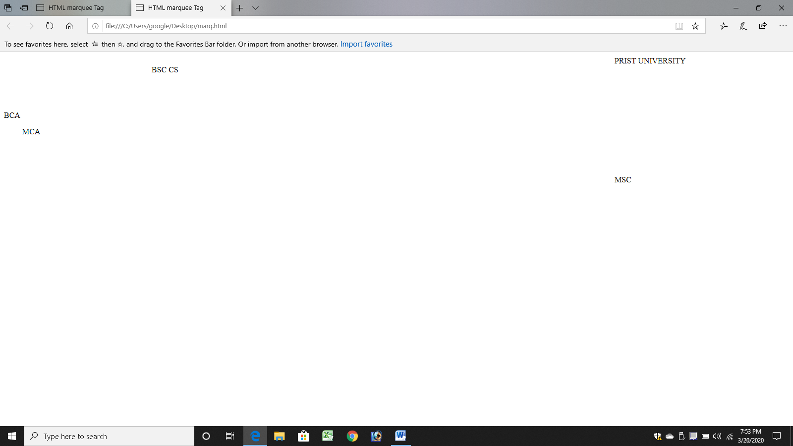

**RESULT:**

Thus a web page using marquee rules has been executed successfully.

**EX.NO:2 MENU CARD**

**DATE:**

**AIM:**

To create a web page using menu card of hotel.

**PROCEDURE:**

1. Start the html, head and title of the page.
2. Using the necessary tags.
3. Mention the table width, height and border.
4. Using the tags <tr> and <td>tags.
5. Close all opened tags.
6. Save the file with extension as filename.html.
7. Run in web browser.

**CODING:**

<html>

<head><center>MENU CARD</center>

<font face="Arial Black" size="7" colour="red">

<title> Catalogue Page</title></head><body>

<table width="10%" height="10%" border="1">

<tr>

<td>ITEM

<br>JUICE

<td>apple<br><td>10</td>

<td>mango<br><td>20</td>

<td>lemon<br><td>15</td>

</tr><tr>

<td>ITEM

<br>FRIED RICE

<td>veg briyani<br><td>180</td>

<td>mushroom briyani<br><td>200</td>

<td>cashew briyani<br><td>215</td>

</tr><tr>

<td>ITEM

<br>STRATERS

<td>french fries<br><td>210</td>

<td>gobi manchurian (dry)<br><td>200</td>

<td>gobi manchurian (gravey)<br><td>215</td>

</tr><tr></tr>

</table></body></html>

**OUTPUT:**

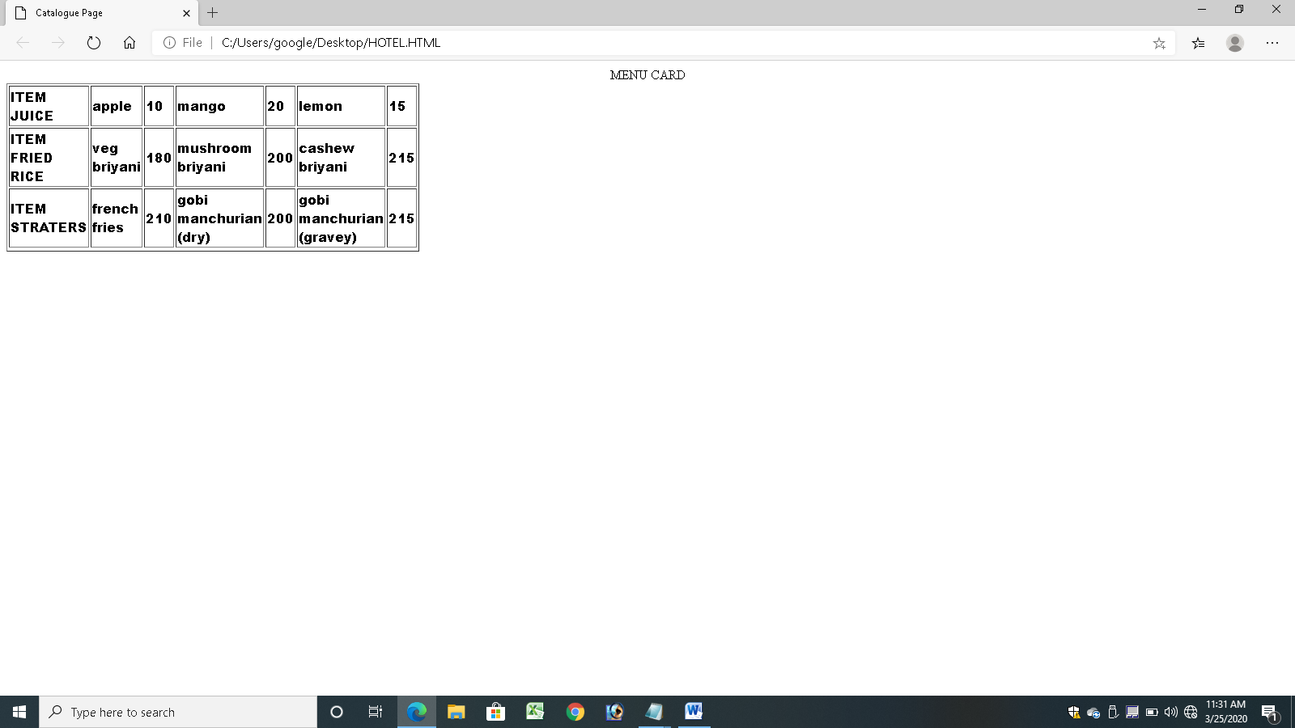

**RESULT:**

Thus a web page using menu card of the hotel has been executed successfully.

**EX.NO: 3 BALANCE SHEETS**

**DATE:**

**AIM:**

To create a web page using the balance sheet for stock of the biscuits company .

**PROCEDURE:**

1. Start the html, head and title of the page.
2. Using the necessary tags.
3. Mention the rowspan and colspan.
4. Using the tags <tr> and <td>tags.
5. Close all opened tags.
6. Save the file with extension as filename.html.
7. Run in web browser.

**CODING:**

<html>

<body><table border=8>

<tr><td colspan="8" align="center">BISCUITS STOCKS LTD</td>

<td align="center">

</tr><tr>

<td rowspan=1><h1>S.NO</h1></td>

<td rowspan=1><h1>ITEM NAME</h1></td>

<td rowspan=1><h1>PRESENT STOCK</h1></td>

<td rowspan=1><h1>AMOUNT</h1></td>

<td rowspan=1><h1>INCOMING STOCK</h1></td>

<td rowspan=1><h1>AMOUNT</h1></td>

<td rowspan=1><h1>OUTGOING STOCK</h1></td>

<td rowspan=1><h1>AMOUNT</h1></td>

</tr>

<td>1</td>

<td>MILK BIKIS</td>

<td>10</td><td>100</td>

<td>20</td><td>200</td>

<td>15</td><td>150</td>

<tr>

<td>2</td>

<td>MARIE GOLD</td>

<td>10</td><td>150</td>

<td>20</td><td>300</td>

<td>10</td><td>150</td>

</tr>

<tr>

<td>3</td>

<td>GOOD DAY</td>

<td>10</td><td>50</td>

<td>30</td><td>150</td>

<td>10</td><td>50</td>

</tr>

<tr>

<td>4</td>

<td>PARLE G</td>

<td>10</td><td150</td>

<td>20</td><td>300</td>

<td>5</td><td>75</td>

</tr>

</table></body></html>

**OUTPUT:**

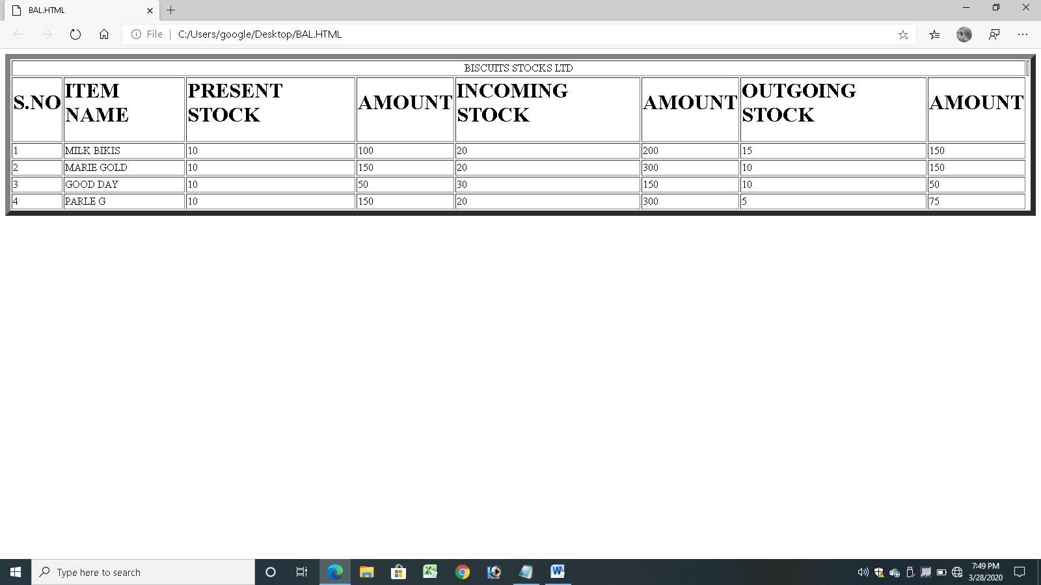

**RESULT:**

Thus a web page using balance sheet for stock of the biscuits company has been executed successfully.

**EX.NO: 4 COMPANY PROFILE**

**DATE:**

**AIM:**

To create a web page using the company profile.

**PROCEDURE:**

1. Start the html, head and title of the page.
2. Using the necessary tags.
3. Using table border cell spacing and cell padding.
4. Mention the rowspan and colspan.
5. Simultaneously using anchor tag <a > and close</a>.
6. Using the tags <tr> and <td>tags.
7. In the main page home ,profile, resume, customer link.
8. Close all opened tags.
9. Save the file with extension as filename.html.
10. Run in web browser.

**CODING:**

<html>

<head>

<title>Head Page</title>

</head>

<body>

<font face="Arial Black" size="3">

<table border="1" cellspacing="2" cellpadding="5" width="100%">

<tr>

<td align="center">

<td colspan="4" align="center">XYZ INFOTECH LTD</td>

</tr>

<tr>

<td align="center"><a href="home.html" target="des_page">HOME</a></td>

<td align="center"><a href="profile.html" target="des_page">PROFILE</a></td>

<td align="center"><a href="resume.html" target="des_page">RESUME</a></td>

<td align="center"><a href="customer.html" target="des_page">CUSTOMER </a></td>

</tr>

</table>

</font>

</body>

</html>

**Home.html**

<html>

<head>

<title>home Page</title>

</head>

<font face="Arial Black" size="4">

<table align="center" height="100%">

<body>

company name: XXX pvt ltd<br>

company address:A8 Industrial Estste,chennai-18.<br>

contact no:9912345678<br>

</table>

</font></body>

</html>

**Profile.html**

<html>

<head>

<title> profile</title>

</head>

<body>

<table width="10%" height="10%" border=1 >

<tr>

<td>

<td>Name:Mr.T.RAGURAM

<br>Designation:TEAM MANAGER

<br>Experience:12</td>

<td>Salary:2LPA</td>

<td>

</tr>

<tr>

<td>

<td>Name:Mr.S.NAGARAJAN

<br>Designation:TEAM LEADER

<br>Experience:8</td>

<td>Salary:1.4LPA</td>

<td>

</tr>

</table>

</body>

</html>

**Resume.html**

<html>

<head><title>resume</title></head>

<body>

<center><b> RESUME</b></center>

<pre>

Name:

Father Name:

Mother Name :

Date of Birth:

Gender:

Religion :

Nationality:

</pre>

<br><br><b>EDUCATIONAL QUALIFICATION</b><br><br>

<table width="80%" cellspacing="3" cellpadding="5" border="3" align="center">

<tr><th>Course<th>School/Institution<th>Year Completed<th>Class Obtained<th>Percentage</tr>

<tr><td>10<td> <td> <td> <td> </tr>

<tr><td>+2<td> <td> <td> <td> </tr>

<tr><td>UG<td> <td> <td> <td> </tr>

</table>

<h4 align="center"><br>Declaration<br></h4>

<font face="Times new roman"> <center> I am declare the above given information is true in my knowledge</font></center><br>

<br><br><p align="right"> </p>

<a href="s1.html">E-Mail Address</a><br>

</body>

</html>

**S1.html**

Enter your mail id:

**Customer.html**

<html>

<head>

<title>customer form</title>

</head>

<body>

<center>

<h3 align="center"><u>customer form</u></h3>

<table border="3">

<tr><td>

<form name="f1" action="" method="post" onsubmit="">

<table cellspacing="10" cellpadding="5">

<tr><td>NAME</td><td><input type="text" size="30" name="uname"/></td></tr>

<tr><td>PASSWORD</td><td><input type="password" size="30" name="pass"/></td></tr>

<tr><td>E-MAIL ID</td><td><input type="text" size="30" name="email"/></td></tr>

<tr><td> PHONE NUMBER</td><td><input type="text" size="15" name="phone"/></td></tr>

<tr>

<td>COMMENTS</td>

<td><textarea name="comments" cols="15" rows="15"></textarea></td></tr>

<tr>

<td>ADDRESS</td>

<td><textarea name="addr" cols="15" rows="15"></textarea></td></tr>

<tr><td colspan="2" align="center"><input type="submit" value="SUBMIT"/>

&nbsp;&nbsp;&nbsp;&nbsp;&nbsp;&nbsp;<input type="reset" value="RESET" /></td>

</tr>

</table>

</form>

</td></tr></table>

</center>

</body>

</html>

**OUTPUT:**

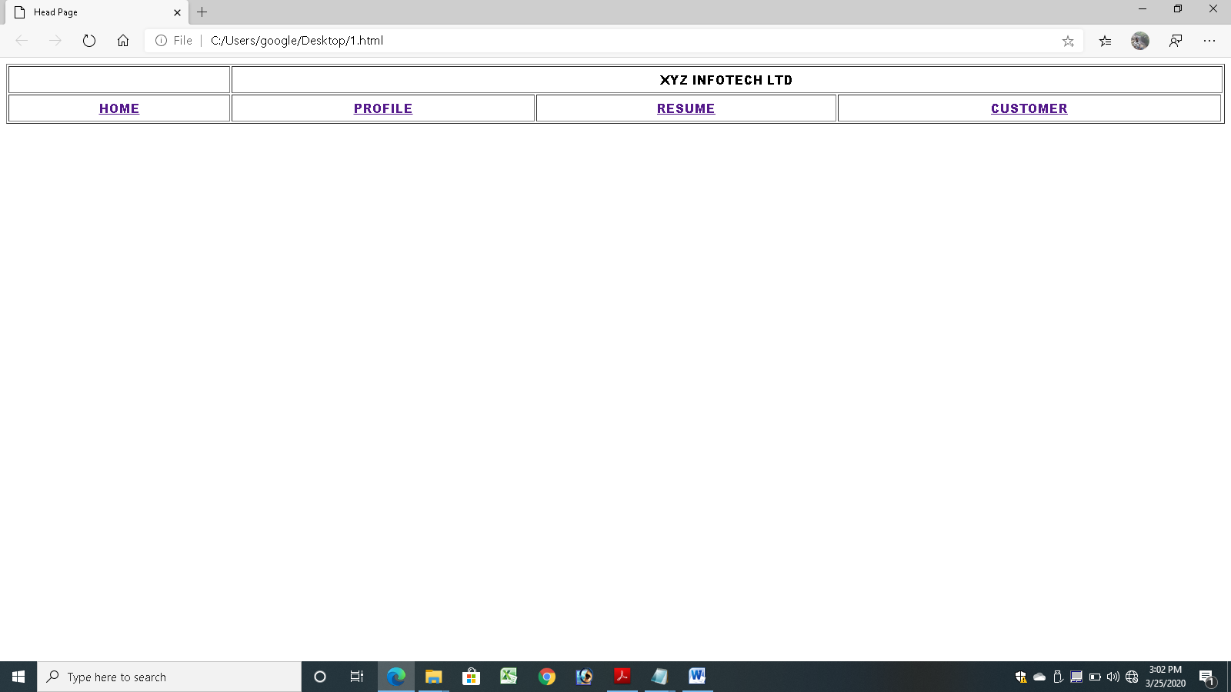

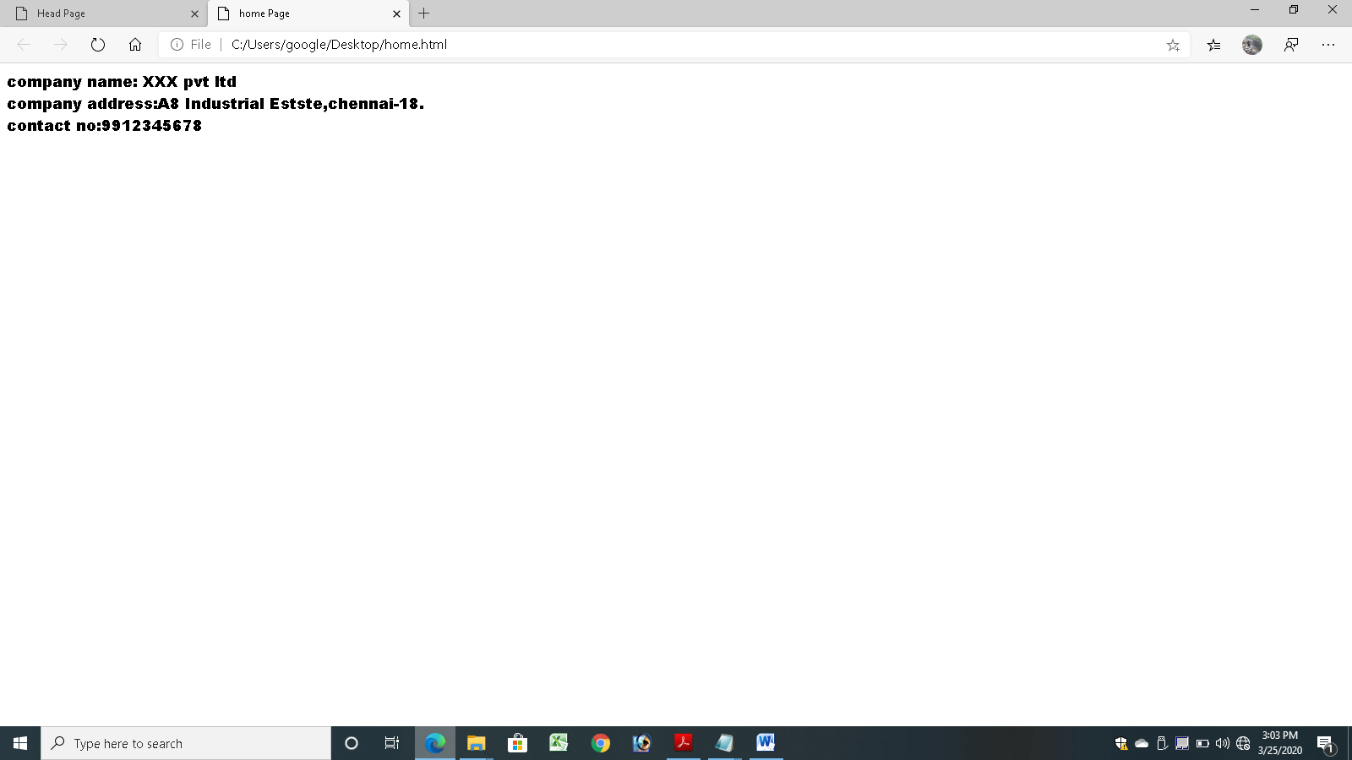

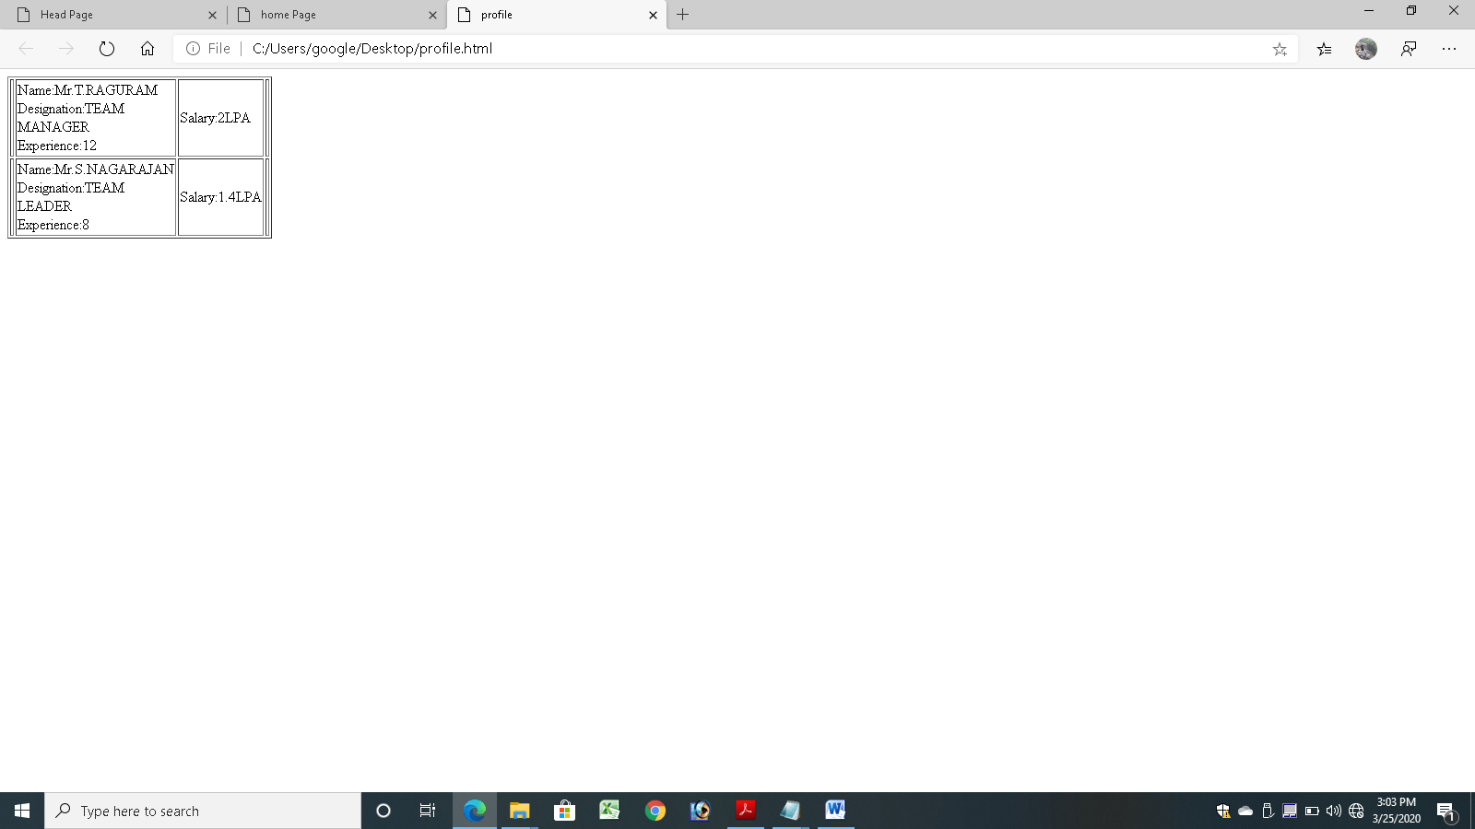

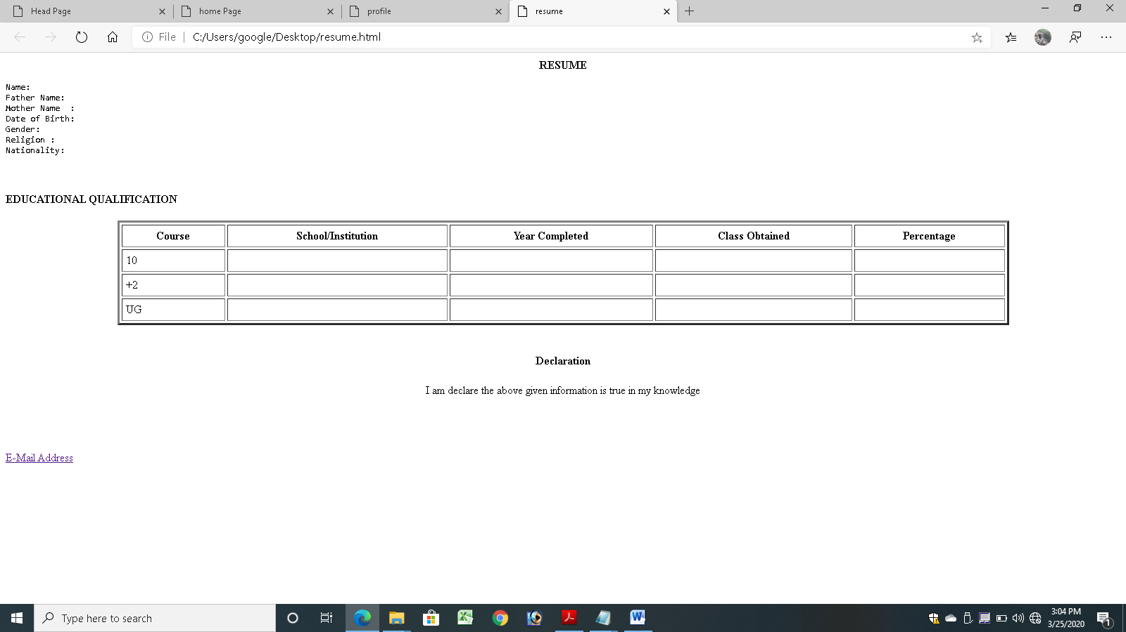

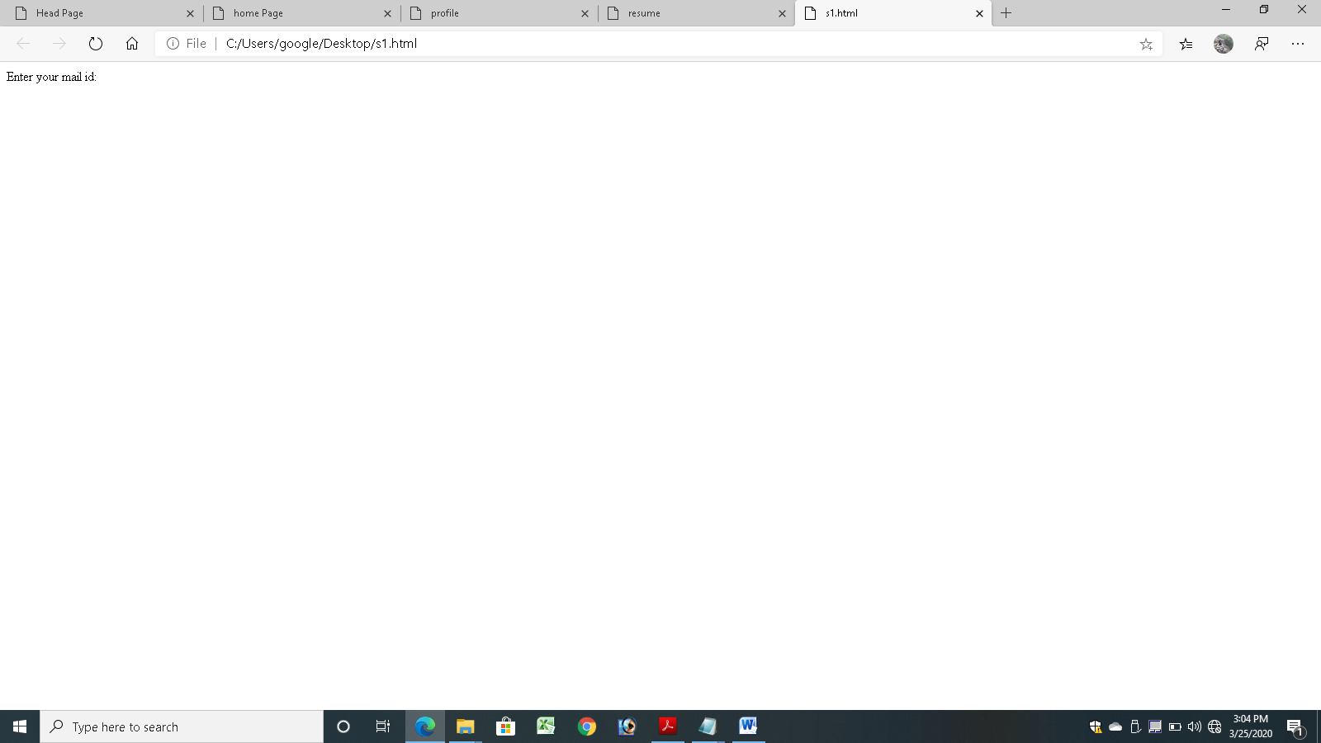

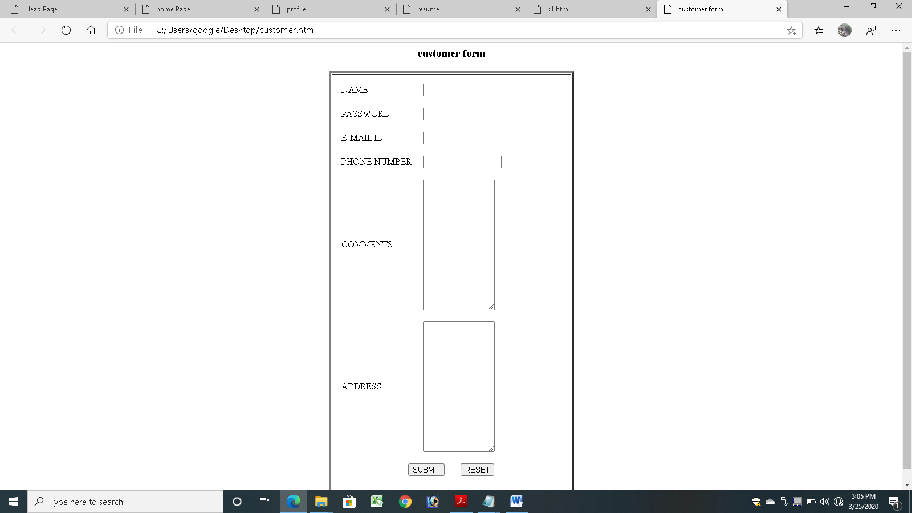

**RESULT:**

Thus a web page using company main page, home page, profile, resume and customer feedback has been executed successfully.

**EX.NO: 5 TRAVEL AGENCY**

**DATE:**

**AIM:**

To create a web page using for travel agency

**PROCEDURE:**

1. Start the html, head and title of the page.
2. Using the necessary tags.
3. Mention the rowspan and colspan.
4. Using the tags <tr> and <td>tags.
5. Close all opened tags.
6. Save the file with extension as filename.html.
7. Run in web browser.

**CODING:**

<html><body><table border=2>

<tr>

<td rowspan=2><h1>name</h1></td>

<td rowspan=2><h1>strating place</h1></td>

<td rowspan=2><h1>destination place</h1></td>

<td rowspan=2><h1>distance</h1></td>

<td rowspan=2><h1>fare</h1></td>

<td colspan=2><h1><center>time</center></h1></tr>

<tr>

<td><b>arrival date and time</b></td>

<td><b>departure date and time</b></td>

</tr></tr>

<td>rock fort exp</td><td>chennai</td><td>trichy</td><td>270km</td>

<td>700</td><td>12-01-2020<br>11</td><td>13-01-2020 <br>17</td></tr>

<td>muthunagar exp</td><td>chennai</td><td>tuticorin</td><td>310km</td>

<td>1200</td><td>14-01-2020<br>15</td><td>15-01-2020 <br>23</td></tr>

<td>pandiyan exp</td><td>chennai</td><td>madurai</td><td>300km</td>

<td>1100</td><td>15-01-2020<br>1</td><td>15-01-2020 <br>7</td></tr>

<td>west coast exp</td><td>chennai</td><td>mangalore</td><td>600km</td>

<td>20000</td><td>17-01-2020<br>11</td><td>18-01-2020 <br>17</td></tr>

</table></body></html>

**OUTPUT:**

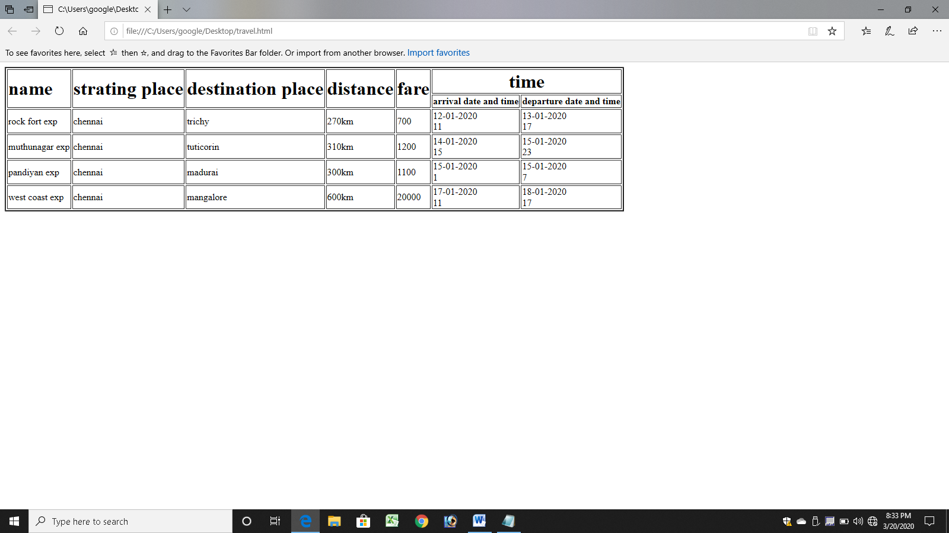

**RESULT:**

Thus a web page using travel agency has been executed successfully.

**EX.NO: 6 REGISTRATION FORM**

**DATE:**

**AIM:**

To create a web page using registration page for admission process.

**PROCEDURE:**

Create a “*registration form* “with the following fields

1) Name (Text field)

2) Password (password field)

3) E-mail id (text field)

4) Phone number (text field)

5) Sex (radio button)

6) Date of birth (3 select boxes)

7) Languages known (check boxes – English, Telugu, Hindi, Tamil)

8) Address (text area)

**CODING:**

<html>

<head>

<title>Registration Page</title>

</head>

<body>

<center>

<h3 align="center"><u>REGISTRATION PAGE</u></h3>

<table border="3">

<tr><td>

<form name="f1" action="" method="post" onsubmit="">

<table cellspacing="10" cellpadding="5">

<tr><td>NAME</td><td><input type="text" size="30" name="uname"/></td></tr>

<tr><td>PASSWORD</td><td><input type="password" size="30" name="pass"/></td></tr>

<tr><td>E-MAIL ID</td><td><input type="text" size="30" name="email"/></td></tr>

<tr><td> PHONE NUMBER</td><td><input type="text" size="15" name="phone"/></td></tr>

<tr><td>GENDER</td><td><input type="radio" name="gen" value="m" />MALE

<input type="radio" name="gen" value="f" />FEMALE </td></tr>

<tr><td>DATE OF BIRTH</td>

<td><select name="day">

<option value="day">DAY</option>

<option value="1">1</option>

<option value="2">2</option>

<option value="3">3</option>

<option value="4">4</option>

<option value="5">5</option>

<option value="6">6</option>

<option value="7">7</option>

<option value="8">8</option>

<option value="9">9</option>

<option value="10">10</option>

<option value="11">11</option>

<option value="12">12</option>

<option value="13">13</option>

<option value="14">14</option>

<option value="15">15</option>

<option value="16">16</option>

<option value="17">17</option>

<option value="18">18</option>

<option value="19">19</option>

<option value="20">20</option>

<option value="21">21</option>

<option value="22">22</option>

<option value="23">23</option>

<option value="24">24</option>

<option value="25">25</option>

<option value="26">26</option>

<option value="27">27</option>

<option value="28">28</option>

<option value="29">29</option>

<option value="30">30</option>

<option value="31">31</option>

</select>

<select name="month">

<option value="month">MONTH</option>

<option value="jan">JANUARY</option>

<option value="feb">FEBRUARY</option>

<option value="mar">MARCH</option>

<option value="apr">APRIL</option>

<option value="may">MAY</option>

<option value="jun">JUNE</option>

<option value="jul">JULY</option>

<option value="aug">AUGUST</option>

<option value="sep">SEPTEMBER</option>

<option value="oct">OCTOBER</option>

<option value="nov">NOVEMBER</option>

<option value="dec">DECEMBER</option>

</select>

<select name="year">

<option value="year">YEAR</option>

<option value="1986">1986</option>

<option value="1987">1987</option>

<option value="1988">1988</option>

<option value="1989">1989</option>

<option value="1990">1990</option>

<option value="1991">1991</option>

<option value="1992">1992</option>

<option value="1993">1993</option>

<option value="1994">1994</option>

<option value="1995">1995</option>

<option value="1996">1996</option>

<option value="1997">1997</option>

<option value="1998">1998</option>

<option value="1999">1999</option>

<option value="2000">2000</option>

<option value="2001">2001</option>

<option value="2002">2002</option>

<option value="2003">2003</option>

<option value="2004">2004</option>

<option value="2005">2005</option>

<option value="2006">2006</option>

<option value="2007">2007</option>

<option value="2008">2008</option>

<option value="2009">2009</option>

<option value="2010">2010</option>

<option value="2011">1980</option>

<option value="2012">1981</option>

<option value="2013">1982</option>

<option value="2014">1983</option>

</select></td></tr>

<tr><td>UNDER GRADUATE</td>

<td><select name="ug">

<option value="SELECT ">SELECT</option>

<option value="BCA">BCA</option>

<option value="BCOM">BCOM</option>

<option value="BBA">BBA</option>

<option value="BSC(CS)">BSC(CS)</option>

<option value="BSC(CHEM)">BSC(CHEM)</option>

<option value="BA(TAMIL)">BA(TAMIL)</option>

</select>

<tr><td>POST GRADUATE</td>

<td><select name="PG">

<option value="SELECT">SELECT</option>

<option value="MCA">MCA</option>

<option value="MCOM">MCOM</option>

<option value="MBA">MBA</option>

<option value="MSC(CS)">MSC(CS)</option>

<option value="MSC(CHEM)">MSC(CHEM)</option>

<option value="MA(TAMIL)">MA(TAMIL)</option>

</select>

<tr><td>LANGUAGES KNOWN</td>

<td>

<input type="checkbox" value="eng" name="lang" />ENGLISH

<input type="checkbox" value="tel" name="lang" />TELUGU

<input type="checkbox" value="hin" name="lang" />HINDI

<input type="checkbox" value="tam" name="lang" />TAMIL

</td></tr>

<tr>

<td>ADDRESS</td>

<td><textarea name="addr" cols="25" rows="5"></textarea></td></tr>

<tr><td colspan="2" align="center"><input type="submit" value="SUBMIT"/>

&nbsp;&nbsp;&nbsp;&nbsp;&nbsp;&nbsp;<input type="reset" value="RESET" /></td>

</tr></table>

</form></td></tr></table></center></body></html>

**OUTPUT:**

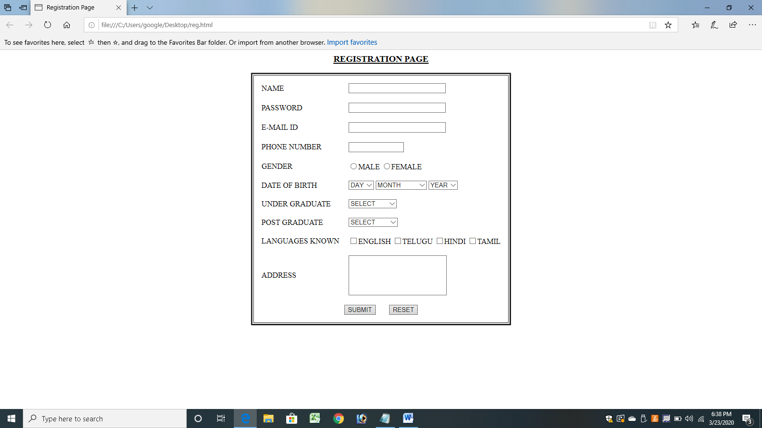

**RESULT:**

Thus a web page for registration form for college admission process has been executed successfully.

**EX.NO: 7 CUSTOMER FEED BACK FORM**

**DATE:**

**AIM:**

To create a web page using customer feedback form

**PROCEDURE:**

1. Start the html, head and title of the page.
2. Using the necessary tags.
3. Mention the form name and action to be present.
4. Using the tags <tr> and <td>tags.
5. In that table mention cell spacing and cell padding.
6. Close all opened tags.
7. Save the file with extension as filename.html.
8. Run in web browser.

**CODING:**

<html><head>

<title>feedback form</title>

</head><body><center>

<h3 align="center"><u>feedback form</u></h3>

<table border="3">

<tr><td>

<form name="f1" action="" method="post" onsubmit="">

<table cellspacing="10" cellpadding="5">

<tr><td>NAME</td><td><input type="text" size="30" name="uname"/></td></tr>

<tr><td>PASSWORD</td><td><input type="password" size="30" name="pass"/></td></tr>

<tr><td>E-MAIL ID</td><td><input type="text" size="30" name="email"/></td></tr>

<tr><td> PHONE NUMBER</td><td><input type="text" size="15" name="phone"/></td></tr>

<tr><td>GENDER</td><td><input type="radio" name="gen" value="m" />MALE

<input type="radio" name="gen" value="f" />FEMALE </td></tr>

<tr><td>DATE OF BIRTH</td>

<td><select name="day">

<option value="day">DAY</option>

<option value="1">1</option>

<option value="2">2</option>

<option value="3">3</option>

<option value="4">4</option>

<option value="5">5</option>

<option value="6">6</option>

<option value="7">7</option>

<option value="8">8</option>

<option value="9">9</option>

<option value="10">10</option>

<option value="11">11</option>

<option value="12">12</option>

<option value="13">13</option>

<option value="14">14</option>

<option value="15">15</option>

<option value="16">16</option>

<option value="17">17</option>

<option value="18">18</option>

<option value="19">19</option>

<option value="20">20</option>

<option value="21">21</option>

<option value="22">22</option>

<option value="23">23</option>

<option value="24">24</option>

<option value="25">25</option>

<option value="26">26</option>

<option value="27">27</option>

<option value="28">28</option>

<option value="29">29</option>

<option value="30">30</option>

<option value="31">31</option>

</select>

<select name="month">

<option value="month">MONTH</option>

<option value="jan">JANUARY</option>

<option value="feb">FEBRUARY</option>

<option value="mar">MARCH</option>

<option value="apr">APRIL</option>

<option value="may">MAY</option>

<option value="jun">JUNE</option>

<option value="jul">JULY</option>

<option value="aug">AUGUST</option>

<option value="sep">SEPTEMBER</option>

<option value="oct">OCTOBER</option>

<option value="nov">NOVEMBER</option>

<option value="dec">DECEMBER</option>

</select>

<select name="year">

<option value="year">YEAR</option>

<option value="1986">1986</option>

<option value="1987">1987</option>

<option value="1988">1988</option>

<option value="1989">1989</option>

<option value="1990">1990</option>

<option value="1991">1991</option>

<option value="1992">1992</option>

<option value="1993">1993</option>

<option value="1994">1994</option>

<option value="1995">1995</option>

<option value="1996">1996</option>

<option value="1997">1997</option>

<option value="1998">1998</option>

<option value="1999">1999</option>

<option value="2000">2000</option>

<option value="2001">2001</option>

<option value="2002">2002</option>

<option value="2003">2003</option>

<option value="2004">2004</option>

<option value="2005">2005</option>

<option value="2006">2006</option>

<option value="2007">2007</option>

<option value="2008">2008</option>

<option value="2009">2009</option>

</select></td></tr>

<tr><td>WORKING CONDITION</td>

<td>

<input type="checkbox" value="good" name="cond" />GOOD

<input type="checkbox" value="fair" name="cond" />FAIR

<input type="checkbox" value="worst" name="cond" />WORST

<input type="checkbox" value="not useful" name="cond" />NOTUSEFUL

</td></tr>

<tr><td>SELECT SOFTWARE</td><td>

<input type="radio" name="python" value="python" />PYTHON

<input type="radio" name="hadoop" value="hadoop" />HADOOP

<input type="radio" name="bigdata" value="bigdata" />BIGDATA

</td></tr><tr>

<td>COMMENTS</td>

<td><textarea name="comments" cols="25" rows="5"></textarea></td></tr>

<tr>

<td>ADDRESS</td>

<td><textarea name="addr" cols="25" rows="5"></textarea></td></tr>

<tr><td colspan="2" align="center"><input type="submit" value="SUBMIT"/>

&nbsp;&nbsp;&nbsp;&nbsp;&nbsp;&nbsp;<input type="reset" value="RESET" /></td>

</tr></table></form></td></tr></table>

</center></body></html>

**OUTPUT:**

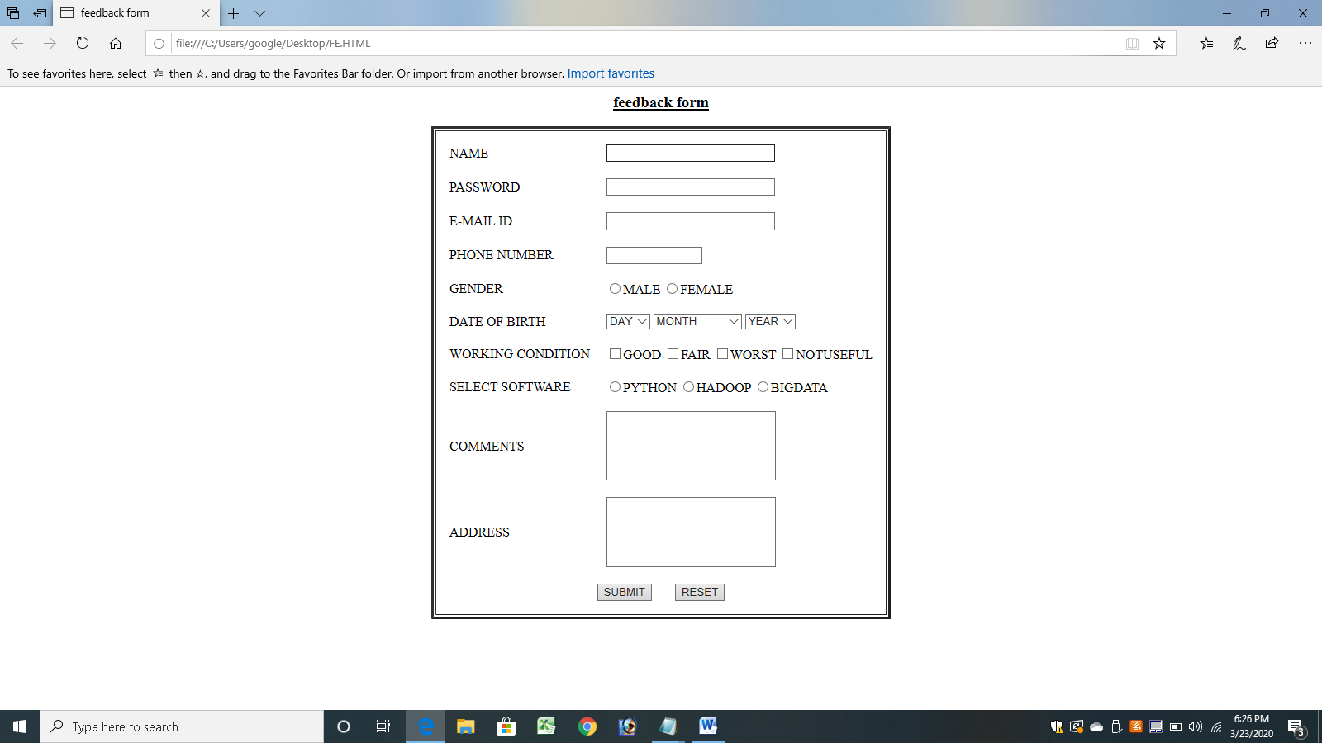

**RESULT:**

Thus a web page for customer feedback form has been executed successfully.